**Using Blockchain in the Retail Sector to Increase Consumer Trust**

Decentralized peer-to-peer transactions are the foundation of blockchain technology. Our blockchain experts work with merchants to maximise this technology's potential for infrastructure development at a fraction of the expense of more conventional centralised approaches.

**Blockchain's advantages for the retail sector**

Blockchain improves the auditability, confidence, and transparency of retail business operations, fostering trust between merchants, payment gateways, and customers.

**Product Agreements**

Through distributed, decentralised, and immutable digital ledger technology, blockchain improves security procedures.

**Eliminate Fake Products**

By determining a product's origin and enabling customers to follow a product's path from start to finish, blockchain technology helps businesses combat product counterfeiting.

**Inventory Control**

By precisely forecasting demand via blockchain, it is feasible to maximise income by lowering the risk of missed sales.

**Personal to Business Transactions**

Benefiting both sides, customers may pay shops utilising blockchain without the usage of any third-party software or extra fees.

**Our Principal Solutions for the Retail Sector**

**Blockchain is being used by emerging power in the retail sector.**

Retailers and companies use blockchain for creative solutions that provide customers direct proof of sustainability and build trust in their products. Additionally, they have connections with retailers' suppliers of builders, distributors, shippers, and other contributors in order to address a variety of business issues that stand between raw materials and finished items on store shelves.

**Increasing customer loyalty**

Data integrity with blockchain technology is immediate and precise. It mostly applies to customer loyalty programmes that rely on data. Every level of client engagement is safe due to the nature of blockchain technology.

Businesses will be able to perform better quality analyses and buyer modelling thanks to this. Blockchain is used by retailers for their customer loyalty programmes. Instead of accumulating rare loyalty points across distant membership programmes, they provide customers the choice to store them in a single wallet.

**Transparency of the supply chain is increased**

Supply chain management, as we all know, relates to the movement of commodities and services. Additionally, it covers all procedures from the procurement of raw materials through the transformation of those resources into final goods.

In any element of eCommerce, the notion of this supply chain is quite complex and difficult to grasp. Blockchain may be used to address problems in the supply chain including detailed record-keeping and comprehensive product tracking.

**Marketplace expansion**

We support the development of blockchain-based smart contract-powered e-commerce platforms that do not use middlemen, third-party payment systems, or transaction manipulation.

**Electronic payments**

We give merchants the tools they need to offer affordable, effective options for international and other types of digital payments.

**Computerized Asset Management**

To plan your digital asset management strategy, we assist you in assessing the advantages of blockchain technology.

**Chain of Supply**

Our blockchain asset tokenization technology improves micropayment supply chain optimization.

**The Peer-to-Peer Market**

We assist with the development of P2P markets with payment and other features, whether it be a fully configurable or SaaS model.

**Our Approach to Development**

**Post Your Question**

We will evaluate the needs of your project and provide an expert engineer or consultant who is most equipped to help you go forward.

**Analyst Conversation**

When it comes time for us to start working on your project, one of our professionals will get in touch with you to thoroughly go through your needs.

**Terms & Conditions of Engagement**

The following phase will entail negotiations with a committed project manager who will outline the precise nature of the job, delivery dates, payment conditions, timetable, management issues, etc.

**Start now**

Following agreement, we execute a contract, and our staff will begin working on your project within 24 hours.

**Why Engage Us For Blockchain POC Development?**

**Ingrained Experience**

We have extensive knowledge and technological experience to create cutting-edge digital contracts with completely adjustable features that are suited for all businesses.

**24 Hour Client Service**

Post-adoption assistance helps smooth the transition, handle adoption concerns and test stability in the early days. Alignment with time zone and process requirements are seamless.

**Cutting-Edge Technology**

We deploy cutting-edge technology, digital protocols, tools, and platforms to improve process transparency and speed up claim settlements.

**Governance and Compliance**

Complete conformity with business policies and laws. Solid documentation to help governance post-implementation.

**360-degree Assistance**

We offer complete smart contract consultancy, Ethereum programming, dApp design and development, and post-deployment maintenance.

**Competence in the industry**

Deep knowledge of many industry-specific procedures, as well as competence in implementing the full range of Blockchain solutions.

**Grammarly screenshot:**

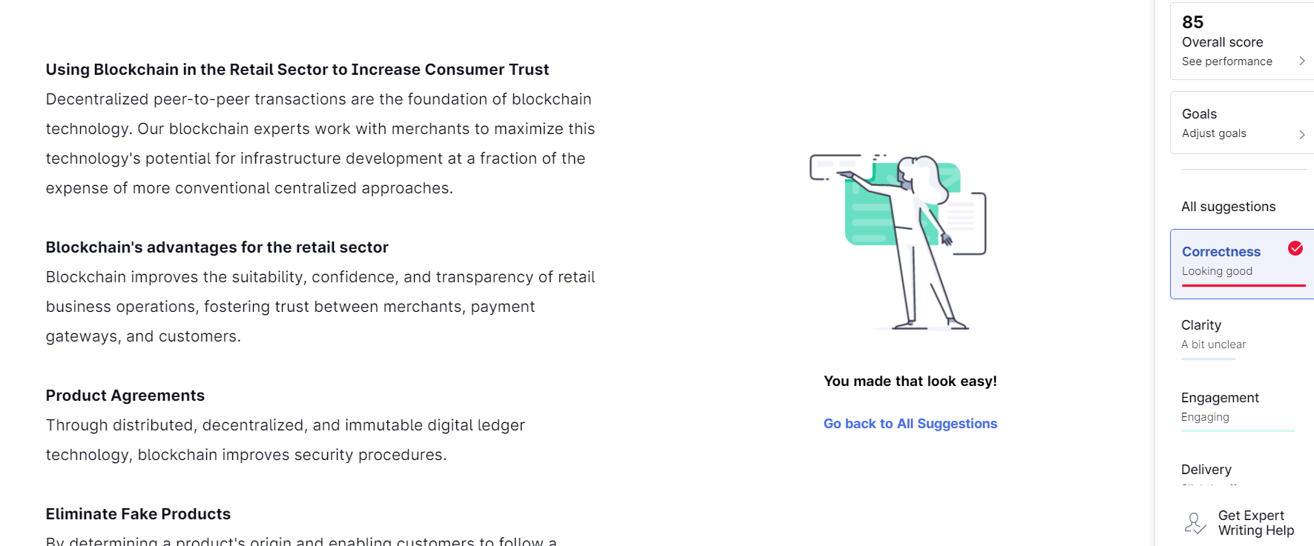

**Plagiarism checker:**

